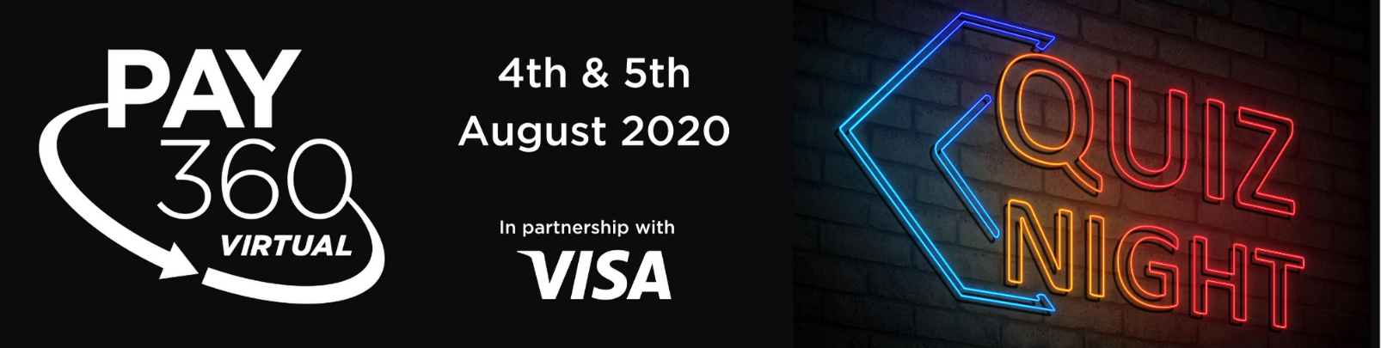
Enter the PAY360 Pub Quiz
Complete the 12 questions and your details below then email your answers to marketing@emergingpayments.org
The answers can all be found throughout the day, and if you think you missed one because you didn’t make the live presentation, they are available to view on demand afterwards.
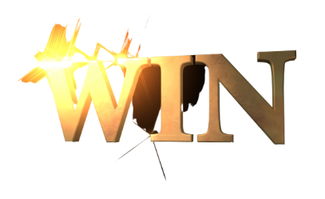
All correct answers will be put into a prize draw to win one of the following prizes:
2 x Echo dot
1 x Alexa
1 x ikettle
Winners will be announced at the end of Day 2.
- How many PAY360 logos can you see in the foyer?
- What colour is Visa’s stand?
- How many stands are there?
- How many video interviews are there in the Mastercard Media Lounge?
- What is the last word Jill Docherty says in her opening keynote presentation?
- Who is the sponsor of the networking lounge?
- What shape is the pendant on Nathalie Oestmann from Curve’s necklace?
- According to the recent EPA Project Inclusion and Inclusion Foundation survey what % of Fintechs does GPS’ Neil Harris say have increased their focus on financially inclusive products since the pandemic?

- Which seller’s logos are featured in Banking Circle’s Innovation Showcase presentation?

- What colour circles are next to the words Mobile Solutions on GPS’s exhibition banner?

- What colour is Tony’s shirt (Day One)?

- What is John Chaplin’s background image?
Name: Company: Email:
Good luck!

